Work Completed So Far -Step by Step

Initial Pipeline (Pre-Review)
Before the current review process began, the following components were already built and individually tested:
- Dataset module (sen12ms_dataset.py) -loads and pairs Sentinel-1 (SAR), Sentinel-2 (EO), and land-cover mask files; applies Prithvi-standard normalisation; verified tensor shapes and label distributions.
- EO-only baseline model (eo_baseline.py) - Prithvi-EO-2.0-300M-TL backbone with a UperNet decoder (~319M parameters); verified a full forward pass on GPU.
- Label scheme and ROI-based split strategy proposed (analysis only).
- Label mapping and deterministic ROI-level splitter implemented.
- Dataset audit script built; a bug was discovered where a single ROI was duplicated across train/val/test when only one ROI was available.
- Bug fixed with explicit disjointness assertions; full SEN12MS winter archive inspected (46 ROIs, ~31,800 patches, ~79GB) and a 4-ROI subset (~2,700 patches, ~6.3GB) selected for laptop-scale prototyping.
- 4-ROI subset extracted and the dataloader verified end-to-end.
- An explicit, manually reasoned train/val/test ROI assignment was set to maximise class coverage per split.

Check Against the Actual Problem Statement
On comparing this initial work against the official problem statement, a significant mismatch was identified:
Aspect | Problem Statement Required | What Had Been Built
Data source | CARTOSAT EO+SAR (ISRO Bhoonidhi) | SEN12MS (Sentinel-1/2, public benchmark)
Classes | 4 classes: Vegetation, Water, Built-up, Land | 9-class IGBP/DFC2020 scheme
Fine-tuning method | LoRA on foundation model | Fully frozen backbone
Physics-informed training | NDVI / NDWI / NDBI as auxiliary features | Not implemented
Labels | Pseudo-labels from spectral-index rules | Real ground-truth labels used directly
Output | Geo-referenced vector layers | Raster segmentation only

Correction Cycle 1 -Fixing the Class Scheme
The 9-class IGBP scheme was replaced with the required 4-class scheme:
Class | Raw IGBP Source Classes
0 -Vegetation | 1–10 (Forest, Shrubland, Grassland, Savanna)
1 -Water | 17
2 -Built-up | 13
3 -Land | 12, 14, 16 (Croplands + Barren)
255 -Ignore | 0, 11 (Wetlands), 15 (Snow/Ice), 255

Correction applied:
Wetlands (raw class 11) was initially proposed as part of Vegetation, but was corrected to Ignore, since wetlands are spectrally and categorically distinct from vegetation and should not be merged into it.

Correction Cycle 2 -Fixing the Train/Val/Test Split
The original 4-ROI split produced severely mismatched class distributions between splits (e.g. Croplands at 51.6% in training but under 1% in validation), making validation scores unreliable. A per-ROI class distribution analysis was run, and three additional ROIs (84, 104, 138) were selected specifically to fill missing class representation (Water and Land in particular). File-count verification confirmed complete extraction of all three modalities (S1, S2, LC) for every new ROI before proceeding.
The final 7-ROI balanced split:
Split | ROIs | Patches | Vegetation | Water | Built-up | Land
Train | 102, 109, 138 | 2,033 | 29.99% | 6.63% | 29.36% | 34.03%
Val | 84, 119 | 1,233 | 42.27% | 18.37% | 29.11% | 10.25%
Test | 108, 104 | 1,291 | 34.52% | 10.41% | 33.48% | 21.59%

Every class now has meaningful representation (above roughly 6%) in every split, and strict ROI-level disjointness (zero geographic overlap between splits) was verified programmatically.

First Legitimate Baseline Result
With the corrected 4-class scheme and balanced split, the frozen-backbone baseline was retrained. Result: 52.51% test mIoU and 67.86% test overall accuracy -a legitimate, trustworthy figure, replacing the earlier meaningless ~13% mIoU obtained under the flawed 9-class/unbalanced-split setup.

Correction Cycle 3 -Addressing Overfitting
Validation mIoU across the 5 training epochs was observed to peak at epoch 1 (43.79%) and decline in every subsequent epoch (down to 27.54% by epoch 5), while training loss kept improving -a clear overfitting signature, given the small dataset size (~2,000 training patches).
Fixes applied:
- Data augmentation added: random horizontal flip, vertical flip, and 90° rotations, applied identically to image and mask, active only on the training split.
- Early stopping introduced: maximum 15 epochs, training halted if validation mIoU does not improve for 3 consecutive epochs.
- Test-set evaluation enabled (previously the test loader was created but never actually evaluated).
Result: training now ran to epoch 7 before early stopping triggered, peaking at epoch 4 (48.25% val mIoU). Test mIoU improved slightly to 53.57%, and Built-up class IoU improved substantially (55.54% → 70.43%). However, Vegetation and Land class performance both worsened slightly (Land recall dropped from 8.75% to 6.20%).

Diagnosing the Land Class Failure
Visual inspection of test prediction panels (RGB input, ground truth, prediction, and error overlay) confirmed that the Land class failure was not a spatial/orientation issue -patches that were 100% Land ground truth were predicted almost entirely as Vegetation or Built-up instead, consistently across multiple samples. This indicated a feature-representation problem: the frozen backbone's features do not sufficiently distinguish Land (bare soil/cropland) from visually similar classes, rather than a problem that augmentation (which only varies spatial orientation) could fix.

Correction Cycle 4 -Class-Weighted Loss + LoRA (In Progress)
Two changes are being introduced together to directly target the Land class failure at its root cause:
- Class-weighted loss: inverse-frequency weights computed from the training set's class distribution, applied to the cross-entropy loss so that errors on rare/hard classes (Land) are penalised more heavily.
- LoRA fine-tuning: small trainable adapter layers inserted into the Prithvi ViT backbone's attention layers (rank 16, alpha 32), allowing the backbone's own features to adapt to this task rather than remaining entirely frozen.
This also brings the project's methodology back into direct alignment with the original problem statement's requirement to use LoRA fine-tuning. This run was in progress at the time of writing; results are pending.

Problems Faced
Problem Identified | Root Cause | Resolution
Work did not match problem statement | Assumed dataset/class scheme without cross-checking against the original brief | Compared explicitly against problem statement; clarified guide's actual intent regarding CARTOSAT reservation
9-class scheme instead of 4-class target | Used dataset's native IGBP taxonomy directly | Built explicit LUT remapping raw IGBP → 4 target classes
Wetlands misclassified as Vegetation | Overly broad class range (1–11) in first draft of mapping | Corrected range to 1–10; Wetlands routed to ignore index
Meaningless validation/test metrics | Train/val/test split had severe class distribution mismatch across ROIs | Per-ROI class distribution analysis; added 3 targeted ROIs; rebalanced split; verified disjointness
Risk of incomplete data extraction | Large archives (13–35GB) with prior history of orphaned/incomplete .tmp extraction files | Explicit per-ROI, per-modality file-count verification before retraining
Test set never evaluated | Test loader created but evaluation loop never invoked in training script | Added explicit test-set evaluation pass after training, logged to metrics file
Overfitting (val mIoU declining after epoch 1) | Small dataset (~2,000 patches), no augmentation, fixed 5-epoch schedule | Added data augmentation and early stopping (patience = 3)
Land class persistently misclassified | Frozen backbone features do not separate Land from visually similar classes; not fixed by augmentation | Diagnosed via visual inspection of prediction panels; addressing with class-weighted loss + LoRA fine-tuning
Training run stopped mid-execution | Interruption of unknown cause during a long run | Checked last saved checkpoint and logs; added resume-from-checkpoint support; continued training rather than restarting from scratch

Visual Outputs and Experiment Evidence
This section presents the actual training curves and test-prediction visualisations generated so far, including the outcome of the LoRA + class-weighted-loss experiment, which surfaced a real training-stability problem. Reporting a failed or broken experiment accurately is itself part of the progress made -it identifies a concrete issue to fix next, rather than leaving it hidden.

Augmented Frozen-Backbone Baseline -Training Curves
This is the successful, trustworthy baseline run: frozen Prithvi backbone, augmentation and early-stopping enabled. Training loss decreases steadily; validation OA and mIoU remain stable across epochs, which is the expected, healthy pattern.
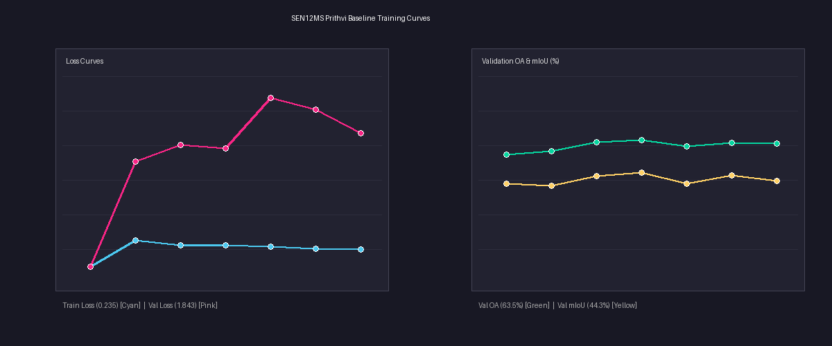
Figure 1. Augmented baseline -training/validation loss and Val OA / mIoU across epochs. Final: Val OA 63.5%, Val mIoU 44.3%.

Augmented Baseline -Test Set Prediction Panels
Each panel shows, left to right: the Sentinel-2 RGB input, the 4-class ground truth, the model's prediction, and an error overlay (red = incorrect pixels). These are drawn from the held-out test ROIs (104 and 108), never seen during training.
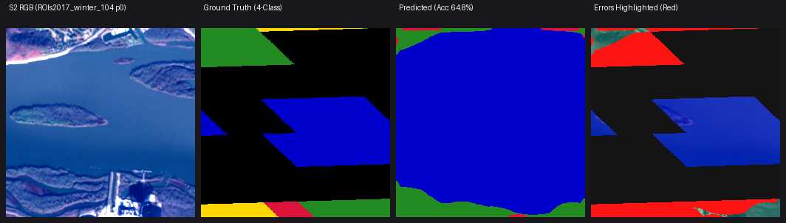
Figure 2. Test patch 104_p0 -Water-dominated scene, 59.9% pixel accuracy. Water is predicted well; boundary regions show most of the error.
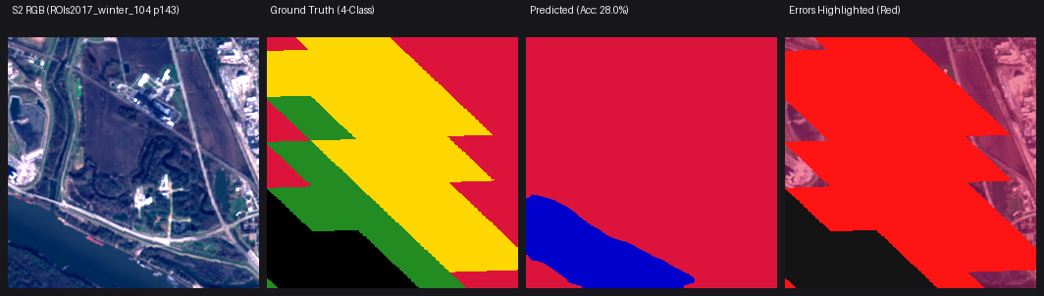
Figure 3. Test patch 104_p143 -mixed scene, 28.4% accuracy. Illustrates confusion between Land (yellow) and Built-up (red).
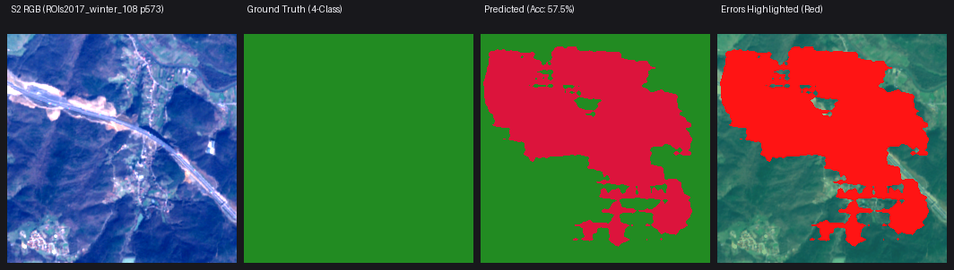
Figure 4. Test patch 108_p573 -Vegetation-dominated scene, 98.9% accuracy -an example of near-perfect prediction.
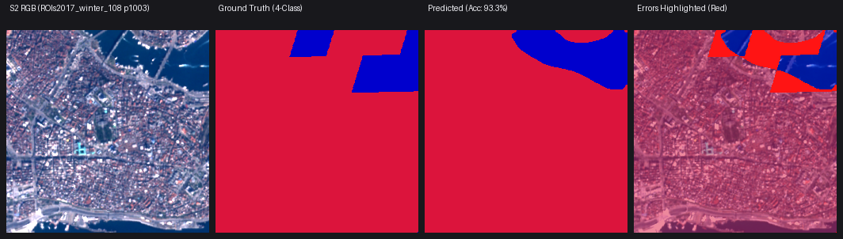
Figure 5. Test patch 108_p1003 -Built-up-dominated scene, 91.7% accuracy, with a small Water region correctly identified.

LoRA + Class-Weighted Loss Experiment -Training Curves
This run was intended to directly target the Land-class weakness observed above. However, the training curve shows a clear numerical failure: both training and validation loss are recorded as NaN (“not a number”), and validation mIoU collapses from an early ~42% down to ~10.6% as training progresses.
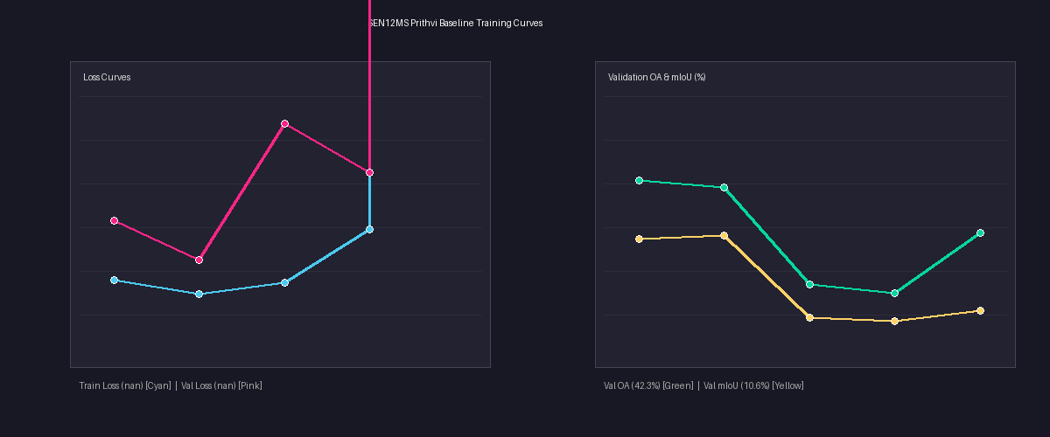
Figure 7. LoRA + class-weighted-loss run -loss becomes NaN partway through training; Val OA and mIoU deteriorate sharply as a result.
Diagnosis:
A NaN loss almost always indicates a numerical breakdown during training -commonly an exploding gradient, an unstable learning rate for the newly added LoRA parameters, or a division-by-zero inside the class-weight calculation (e.g. a class with very few pixels in a given batch). Once loss becomes NaN, the model continues updating on meaningless gradients, and any checkpoint saved afterward is unreliable regardless of its reported metric. This has been logged as an open issue to debug before this experiment's results can be trusted.

LoRA + Class-Weighted Loss -Test Panels (Same Patches, for Direct Comparison)
The same test patches shown in Section 8.2 are reproduced here using the LoRA + class-weighted checkpoint, to directly compare against the healthy baseline. Several patches that the baseline handled well are noticeably worse here -consistent with the training breakdown seen in Figure 7.
Figure 8. Test patch 104_p0 under LoRA+weighted -64.8% accuracy (baseline: 59.9%) -one of the few patches that improved.
Figure 9. Test patch 108_p573 under LoRA+weighted -57.5% accuracy, a sharp drop from the baseline's 98.9% on the same patch.

LoRA + Class-Weighted Loss -Dedicated Land-Class Panels
To specifically check whether the Land class improved, five additional test patches with 100% Land ground truth were evaluated. The results show the intended fix did not succeed -accuracy on these patches is close to 0% in nearly every case, in some cases now confidently predicting the wrong class across the entire patch rather than a partial/mixed error.
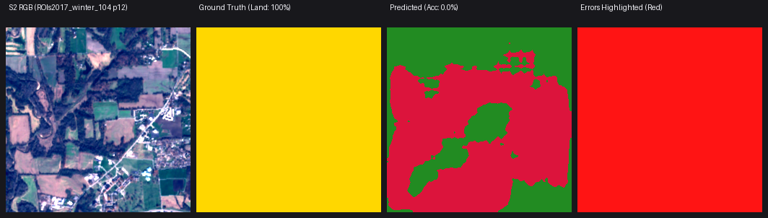
Figure 10. 100% Land ground truth, 0.0% accuracy -predicted almost entirely as Built-up/Vegetation.
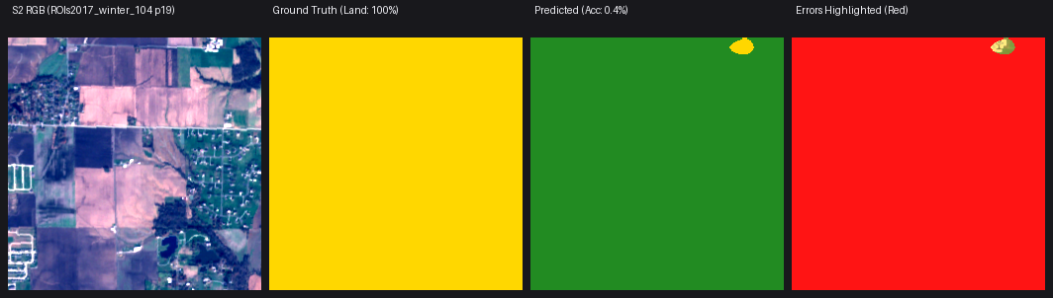
Figure 11. 100% Land ground truth, 0.4% accuracy -predicted almost entirely as Built-up.
Full results across all five dedicated Land patches (p12, p13, p14, p19, p20): accuracy of 0.0%, 0.0%, 0.0%, 0.4%, and 1.4% respectively -confirming the Land-class problem is not yet resolved, and that this particular experiment requires the NaN training issue to be fixed and re-run before it can be evaluated fairly.

Current Status and Next Steps

Completed and Verified
- Data pipeline (EO loading, normalisation, ROI-based pairing) -built and verified.
- 4-class label scheme, corrected and verified (including the Wetlands correction).
- Balanced, disjoint 7-ROI train/val/test split -built and verified.
- Frozen-backbone baseline trained and properly evaluated on a held-out test set (52.51% → 53.57% test mIoU across iterations).
- Overfitting diagnosed and addressed via augmentation and early stopping.
- Land class failure diagnosed via visual inspection as a feature-representation issue, not a data-orientation issue.

In Progress
- LoRA fine-tuning of the Prithvi backbone combined with class-weighted loss, targeting the Land class specifically. First attempt (see Section 8) failed due to a NaN loss during training; the numerical cause needs to be debugged and the experiment re-run before results can be evaluated.

Not Yet Started
- EO + SAR multi-modal fusion.
- Physics-informed training using NDVI / NDWI / NDBI spectral indices.
- Spectral-index-based pseudo-labelling.
- Vectorisation of raster predictions into geo-referenced vector layers.
- Acquisition and integration of actual CARTOSAT imagery from the ISRO Bhoonidhi portal (reserved for final testing, per guide instruction).

Correction Cycle 5 — ESA WorldCover Ground-Truth Replacement
Rather than continuing to debug the NaN loss from the Correction Cycle 4 LoRA + class-weighted-loss run in isolation, a deeper audit was carried out first. This audit found a second, more serious problem sitting underneath the NaN instability: the fine-tuning checkpoint had been trained under a legacy label mode that mapped the Vegetation class (class 0) to the ignore index, meaning the model received zero training signal for Vegetation regardless of the loss instability. Combined, these two issues made the Correction Cycle 4 results unusable. Rather than patch this checkpoint, the decision was made to rebuild the ground-truth pipeline entirely using ESA WorldCover 10m labels (a 50x resolution improvement over the MODIS-derived 500m labels used until this point) and retrain from a fresh backbone and fresh LoRA adapters.

Ground-Truth Quality Audit
Before trusting the new WorldCover-based labels for training, the ground truth was independently audited across four dimensions:
Check | Result | Verdict
Spatial alignment (CRS, bounds, transform) | 20 randomly sampled patches across all 7 ROIs matched exactly (0.0 m difference) between Sentinel-2 and WorldCover rasters | Passed
LUT / class-code completeness | All 11 raw ESA WorldCover codes (10–100) accounted for in the 4-class mapping; none silently dropped | Passed
Temporal alignment | WorldCover ground truth is dated 2020 (v100); Sentinel-2 imagery is dated 2017 — a 3-year gap with no matching 2017 WorldCover product available | Known limitation
Tile-stitch integrity | 89 of 4,557 patches (54 in ROI 102, 35 in ROI 104) contain internal no-data seams from imperfect multi-tile mosaicking | Confirmed negligible impact

Note on the temporal gap:
this is a known, unavoidable limitation of pairing the fixed 2017 SEN12MS imagery with WorldCover (only available for 2020/2021). It is reported here as a documented caveat, not a resolved issue. Investigating Google Dynamic World (a per-scene, same-date land-cover product) as a replacement label source is listed under Next Steps below.

Retraining and Checkpoint Selection
- Backbone: Prithvi-EO-2.0-300M (pretrained, frozen — 303.89M parameters)
- LoRA adapters re-applied to self-attention projection layers (qkv, proj), rank r=16, α=32, dropout 0.1 — 17.48M trainable parameters (5.44% of total)
- Loss: log-smoothed inverse-class-frequency weighted CrossEntropyLoss ([0.672, 1.246, 1.134, 1.038]), ignore_index=255 — replacing the unweighted loss that produced the earlier NaN instability
- Optimizer: AdamW (lr=1e-4), CosineAnnealingLR, mixed precision (FP16), trained for 10 epochs on the corrected 7-ROI split
Per-epoch validation tracking (ROI 84) showed validation mIoU peaked at Epoch 2 (55.16%) and declined in every subsequent epoch, down to 40.43% by Epoch 10 — even as Vegetation IoU in isolation kept climbing to a peak of 92.41% at Epoch 7. This is the same overfitting signature identified in Correction Cycle 3, occurring again here: the model over-committed capacity to the dominant Vegetation class at the expense of the others, most visibly in Water recall, which fell from 96.6% (Epoch 2) to 25.8% (Epoch 10). The checkpoint saved as “best” (by validation mIoU) was directly verified against its saved metadata and confirmed to correctly correspond to Epoch 2, not a later, degraded epoch.

Final Test Results (Held-Out ROI 104, 508 Patches)
Class | IoU (%) | F1 (%) | Precision (%) | Recall (%)
Vegetation | 66.87 | 80.15 | 74.68 | 86.48
Water | 85.81 | 92.36 | 91.57 | 93.17
Built-up | 46.14 | 63.14 | 51.16 | 82.47
Land | 50.39 | 67.01 | 91.42 | 52.89

Overall Accuracy: 75.07% | Mean IoU: 62.30% | Test Loss: 0.5903
Re-evaluating on the 473 “clean” ROI 104 patches (excluding the 35 seam-affected ones) changed mIoU by only –0.12%, confirming the tile-stitch seams identified in the audit have a negligible effect on reported performance.

Land Class Diagnosis — Updated Confusion Matrix
Correction Cycle 3 diagnosed the Land-class failure via visual inspection as a feature-representation problem (Land confused with visually similar classes) rather than a data-orientation issue. The full confusion matrix from this retrained model confirms and quantifies that diagnosis precisely:
Ground Truth | Pred: Vegetation | Pred: Water | Pred: Built-up | Pred: Land
Vegetation | 12,819,581 | 124,208 | 1,571,682 | 308,841
Water | 97,156 | 2,616,140 | 30,925 | 63,724
Built-up | 461,747 | 19,758 | 3,123,120 | 182,390
Land | 3,787,016 | 96,970 | 1,379,702 | 5,909,766

Of all true Land pixels, 33.9% are misclassified as Vegetation — the model’s single largest confusion — versus 12.4% as Built-up and under 1% as Water. This is consistent with genuine spectral similarity between sparse cropland/bare soil and low-density vegetation, rather than a training or pipeline defect. Land precision remains high (91.4%): the model rarely over-predicts Land, it under-predicts it. This is an improvement over the Correction Cycle 3 baseline (where dedicated 100%-Land test patches scored 0–8% accuracy) but the underlying confusion is not fully resolved.

Visual Outputs — WorldCover-Retrained Model, Test Predictions (ROI 104)
Four held-out ROI 104 test patches, shown as Sentinel-2 RGB input, 4-class ground truth, and model prediction. The over-extension of Built-up (red) beyond its true boundaries and the loss of fine Land (pink) parcels into Vegetation are visible directly in patches 3 and 4, matching the confusion-matrix findings above.
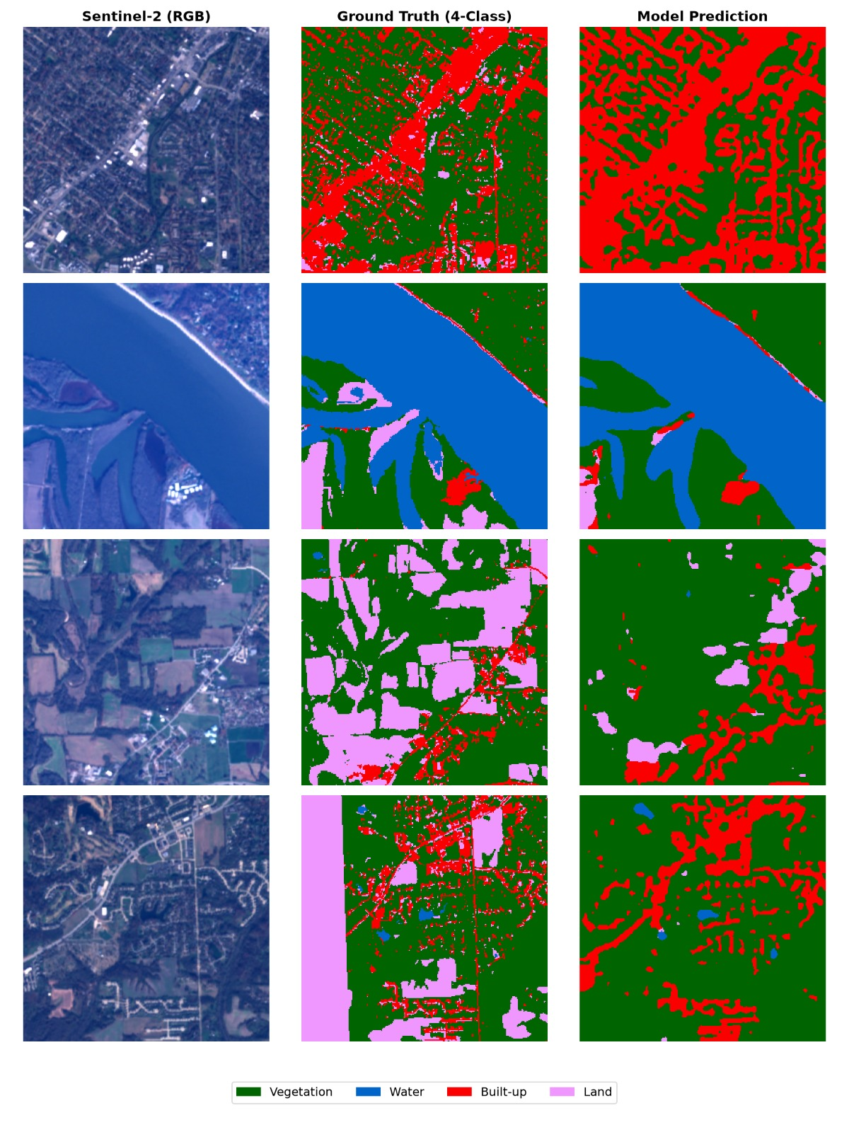
Figure 12. WorldCover-retrained model — test set prediction panels (Sentinel-2 RGB / Ground Truth / Prediction) across four ROI 104 patches, illustrating Built-up over-prediction and Land–Vegetation confusion.

Updated Status and Next Steps

Resolved Since Last Update
- The Correction Cycle 4 NaN-loss failure and its underlying corrupted-checkpoint cause (Vegetation silently mapped to ignore) — fixed via ground-truth pipeline rebuild and full retrain.
- Ground-truth pipeline independently audited for spatial alignment, class-code completeness, and tile-stitch integrity — all confirmed sound or confirmed negligible in impact.
- Checkpoint selection verified correct (Epoch 2, best validation mIoU) against saved metadata, ruling out use of an overfit later-epoch checkpoint.
- Code and notebooks pushed to GitHub for backup and reproducibility (data and checkpoints excluded via .gitignore).

Still Open
- Land–Vegetation confusion (33.9% of true Land pixels): improved from the Correction Cycle 3 baseline but not resolved — a genuine spectral-similarity limitation, not a pipeline defect.
- Built-up over-prediction (51.2% precision vs. 82.5% recall) and generally coarse, blocky prediction boundaries relative to ground truth, likely a consequence of the ViT’s 16×16 patch tokenization.
- The 2017-imagery / 2020-label temporal gap remains unresolved within this dataset.

Not Yet Started
- Investigating Google Dynamic World as a same-date (per-scene) label source to eliminate the temporal gap without a full new imagery-acquisition effort.
- EO + SAR multi-modal fusion; physics-informed NDVI/NDWI/NDBI training; spectral-index pseudo-labelling; vectorisation into geo-referenced vector layers; CARTOSAT imagery integration (all as previously listed, still pending).

